Data Science Project 2018

TEAM 16



Analysis and Interpretation of Data

Edgar Meireles, ist424755 (83451)
Francisco Centeno, ist424765 (83461)
Paulo Revés, ist424840 (83537)

Contents
1. Introduction 2
2. Pre-processing 2
2.1 Non-Supervised Learning 2
2.1.1 Problem 1 2
2.1.2 Problem 2 2
2.1 Classification 2
2.1.1 Problem 1 2
2.1.2 Problem 2 2
3. Exploration 2
3.1 Non-Supervised Learning 2
3.1.1 Problem 1 2
3.1.1.1 Methods and Parametrization 2
3.1.1.2 Results 2
3.1.2 Problem 2 3
3.1.2.1 Methods and Parametrization 3
3.1.2.2 Results 3
3.1 Classification 2
3.1.1 Problem 1 2
3.1.1.1 Methods and Parametrization 2
3.1.1.2 Results 2
3.1.2 Problem 2 3
3.1.2.1 Methods and Parametrization 3
3.1.2.2 Results 3
4. Critical Analysis 3
5. Conclusions 3
References 3
Attachements 3

1. Introduction
For this project we were expect to analyze and understand the information from two different datasets, using techniques and algorithms learned on the course.
The first dataset is about Air Pressure system (APS) which generates pressurized air that is utilized in heavy trucks. The attributes from this dataset were anonymized for proprietary reasons. The dataset is composed by 60000 records each with 171 attributes. After analyzing the information we found that the target variable was the class, composed of two nominal values “neg” if the failures for the components are not related to the APS and “pos” if they are.
The second one is about Colposcopies this dataset explores the subjective quality assessment of digital colposcopies, studied at Hospital Universitario de Caracas. The dataset has three modalities (i.e. Hinselmann, Green and Schiller) each with 69 attributes (62 predictive attributes, 7 target variables). The Green dataset has 98 records, Hinselmann 97 records and Schiller 92 records.

2. Pre-processing

Non-Supervised Mining

Problem 1

Problem 2
With the Colposcopies datasets we applied the KMeans algorithm since the number of records and attributes was relatively small. We started by separating the “concensus” target class from the rest of the information, and then applied the algorithm doing this for each of the datasets.

Classification

Problem 1
With the Colposcopies datasets we started by separating the “concensus” target class from the rest of the information, then split into training and test sets, balancing the training set. We applied this for each of the datasets.

Problem 2
With the APS Failure at Scania Trucks dataset we started by transforming the attribute class from nominal to binary doing this to both the training and test set. We then balance the training set data increasing the lowest count class to have the same value as the major one, being “pos” the lowest one with 1000 records and “neg” the biggest one with 59000. But we still have missing values in some attributes of the dataset; we fill them with different values based on the attribute to observe which deliver the best results (0, min, max, mean, interpolated).

Exploration

Non-Supervised Mining

Problem 1

Methods and Parametrization
The goal of KMeans Clustering is to find groups in the data, where the number of groups is given by the K variable. The algorithm assigns each data point to one of the K groups based on the distance to the cluster center. To discover the K variable, we used the Elbow Curve Method, assigning different values to K and using the Euclidean distance between each data point with the cluster center. Plotting a graph with the variation of K and the distance, we can notice that the distance decreases as K gets larger. This happens because when you have more clusters, they will be smaller, so the distance between the data points and the cluster center will also be smaller. Figure X.

Results

Problem 2

Methods and Parametrization

Results

Classification

Problem 1

Methods and Parametrization
The algorithms used are KNN, Naïve Bayes, CART (Decision Tress) and Random Forest.

Results
Green | KNN = 5 | Naïve Bayes | CART | Random Forest
Confusion matrix | [[ 7 2]  [ 8 13]] | [[ 5 4]  [ 1 20]] | [[ 6 3]  [ 0 21]] | [[ 7 2]  [ 5 16]]
Accuracy | 0.6666(6) | 0.8333(3) | 0.90000 | 0.7666(6)
Error Rate | 0.3333(3) | 0.1666(6) | 0.10000 | 0.2333(3)
Precision | 0.7777(7) | 0.5555(5) | 0.6666(6) | 0.7777(7)
Specificity | 0.61905 | 0.95238 | 1.00000 | 0.76190
FP rate | 0.1333(3) | 0.1666(6) | 0.12500 | 0.1111(1)
TP rate | 0.35000 | 0.20000 | 0.2222(2) | 0.30435

Hinselmann | KNN = 5 | Naïve Bayes | CART | Random Forest
Confusion matrix | [[ 1 4]  [10 15]] | [[ 2 3]  [ 5 20]] | [[ 2 3]  [ 4 21]] | [[ 2 3]  [ 2 23]]
Accuracy | 0.5333(3) | 0.7333(3) | 0.7666(6) | 0.8333(3)
Error Rate | 0.4666(6) | 0.2666(6) | 0.2333(3) | 0.1666(6)
Precision | 0.20000 | 0.40000 | 0.40000 | 0.40000
Specificity | 0.60000 | 0.80000 | 0.84000 | 0.92000
FP rate | 0.21053 | 0.13043 | 0.12500 | 0.11538
TP rate | 0.06250 | 0.0909(09) | 0.08696 | 0.08000

Schiller | KNN = 5 | Naïve Bayes | CART | Random Forest
Confusion matrix | [[ 5 3]  [ 3 17]] | [[ 7 1]  [ 1 19]] | [[ 8 0]  [ 3 17]] | [[ 7 1]  [ 4 16]]
Accuracy | 0.78571 | 0.92857 | 0.89286 | 0.82143
Error Rate | 0.21429 | 0.07143 | 0.10714 | 0.17857
Precision | 0.62500 | 0.87500 | 1.00000 | 0.87500
Specificity | 0.85000 | 0.95000 | 0.85000 | 0.80000
FP rate | 0.15000 | 0.05000 | 0.00000 | 0.05882
TP rate | 0.227(27) | 0.26923 | 0.32000 | 0.30435

Problem 2

Methods and Parametrization
The algorithms used are KNN, Naïve Bayes, CART (Decision Tress) and Random Forest. We run them with different datasets depending on the values filled for the missing values. Changing some of the parameters for KNN and CART based on the accuracy depending on the number of neighbors and accuracy depending on the depth, figure x and x respectively.

Results
NaN value(0) | KNN = 5 | Naïve Bayes | CART | Random Forest
Confusion matrix | [[15425 200]  [ 92 283]] | [[15136 489]  [ 36 339]] | [[15532 93]  [ 156 219]] | [[15599 26]  [ 148 227]]
Accuracy | 0.98175 | 0.96719 | 0.98444 | 0.989125
Error Rate | 0.01825 | 0.03281 | 0.01556 | 0.989125
Precision | 0.98720 | 0.96870 | 0.99405 | 0.99834
Specificity | 0.7546(6) | 0.90400 | 0.58400 | 0.6053(3)
FP rate | 0.41408 | 0.59058 | 0.29808 | 0.10277
TP rate | 0.98198 | 0.97809 | 0.98610 | 0.98566

NaN value(min) | KNN = 5 | Naïve Bayes | CART | Random Forest
Confusion matrix | [[15425 200]  [ 92 283]] | [[15136 489]  [ 36 339]] | [[15543 82]  [ 156 219]] | [[15593 32]  [ 136 239]]
Accuracy | 0.98175 | 0.96719 | 0.98513 | 0.98950
Error Rate | 0.01825 | 0.03281 | 0.01488 | 0.01050
Precision | 0.98720 | 0.96870 | 0.99475 | 0.99800
Specificity | 0.7546(6) | 0.90400 | 0.58400 | 0.6373(3)
FP rate | 0.41408 | 0.59058 | 0.27243 | 0.11808(11808)
TP rate | 0.98198 | 0.97809 | 0.98611 | 0.98490

NaN value(max) | KNN = 5 | Naïve Bayes | CART | Random Forest
Confusion matrix | [[15251 374]  [ 229 146]] | [[14398 1227]  [ 98 277]] | [[15558 67]  [ 146 229]] | [[15601 24]  [ 141 234]]
Accuracy | 0.96231 | 0.91719 | 0.98669 | 0.98969
Error Rate | 0.03769 | 0.08281 | 0.01331 | 0.01031
Precision | 0.97606 | 0.92147 | 0.99571 | 0.99846
Specificity | 0.3893(3) | 0.7386(6) | 0.6106(6) | 0.62400
FP rate | 0.71923 | 0.81582 | 0.226351 | 0.09302
TP rate | 0.99052 | 0.98112 | 0.985494 | 0.98522

NaN value(mean) | KNN = 5 | Naïve Bayes | CART | Random Forest
Confusion matrix | [[15092 533]  [ 88 287]] | [[15172 453]  [ 41 334]] | [[15522 103]  [ 197 178]] | [[15604 21]  [ 192 183]]
Accuracy | 0.96119 | 0.96913 | 0.98125 | 0.98669
Error Rate | 0.03881 | 0.03088 | 0.01875 | 0.01331
Precision | 0.96589 | 0.97101 | 0.99341 | 0.99866
Specificity | 0.7653(3) | 0.8906(6) | 0.4746(6) | 0.48800
FP rate | 0.65000 | 0.57560 | 0.36655 | 0.10294
TP rate | 0.98134 | 0.97846 | 0.98866 | 0.98841

Critical Analysis
Below as attachments are the Roc chart graphs for each Algorithm with different missing values, in conformity with the results given for each dataset.
As the report had a limit of 10 pages for contents and for the sake of being able to properly analyze it, we also deliver with the code an extra folder with some bigger attachments, showing the decision tree for the CART algorithm. The Trees were made for both problems, with an extra for the second problem with only the five most predominant attributes.

Conclusions

References
- (2018, August 5). Working with missing data. https://pandas.pydata.org/pandas-docs/stable/missing_data.html
- D’Souza, Jocelyn (2018, March 15). Let’s learn about AUC ROC Curve! https://medium.com/greyatom/lets-learn-about-auc-roc-curve-4a94b4d88152?fbclid=IwAR0ua-JrL5IMb91zO0Ic2H1JH8kiKhynBlQrIRstSL88dHnCNff0oPJDsEk

AttAchements

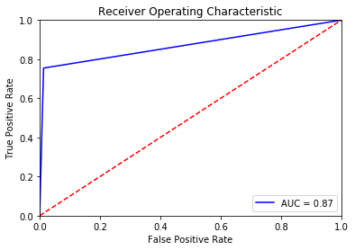
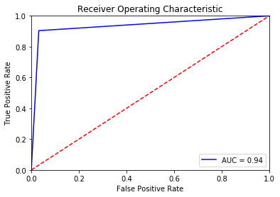
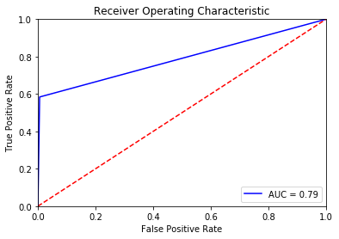
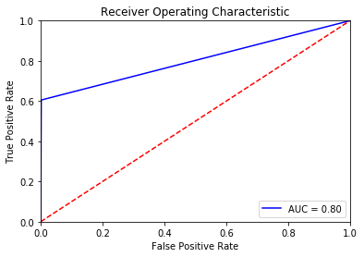
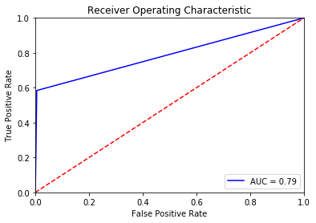
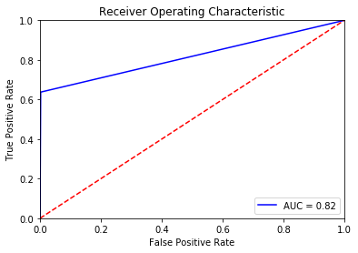
Figure 1 – KNN (NaN -> 0)
Figure 2 – Naïve Bayes (NaN -> 0)

Figure 3 – CART (NaN -> 0)

Figure 8 – Random Forest (NaN -> Min)

Figure 4 – Random Forest (NaN -> 0)

Figure 5 – KNN (NaN -> Min)

Figure 6 – Naïve Bayes (NaN -> Min)

Figure 7 – CART (NaN -> Min)
Problem 1 - Classification

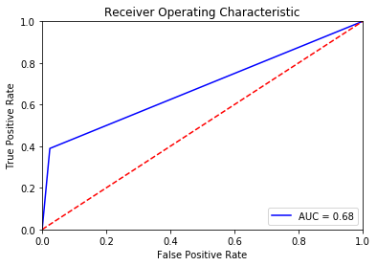
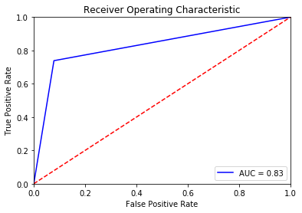

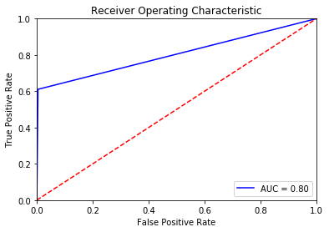
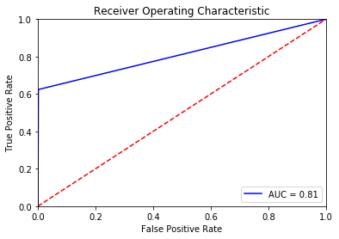
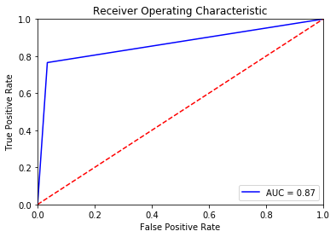
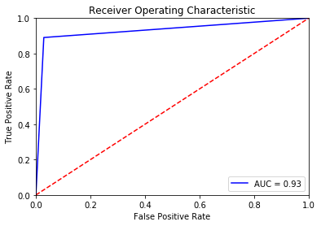
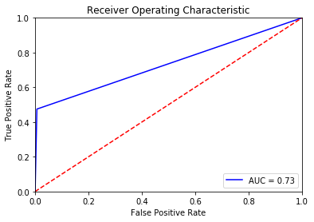
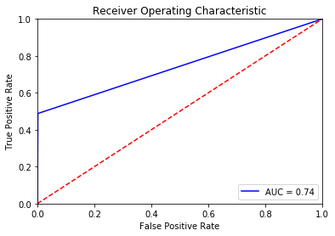
Figure 9 – KNN (NaN -> Max)

Figure 10 – Naïve Bayes (NaN -> Max)
Figure 11 – CART (NaN -> Max)
Figure 12 – Random Forest (NaN -> Max)
Figure 13 – KNN (NaN -> Mean)
Figure 14 – Naïve Bayes (NaN -> Mean)

Figure 15 – CART (NaN -> Mean)
Figure 16 – Random Forest (NaN -> Mean)

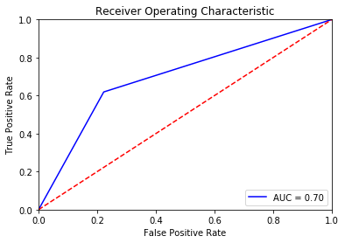
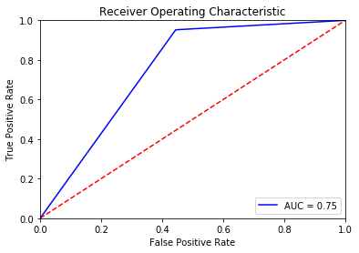
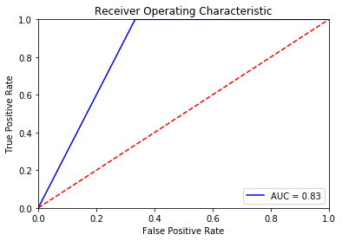
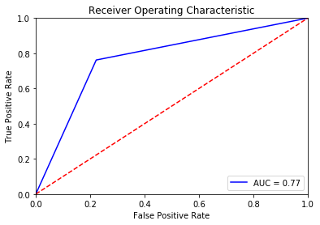
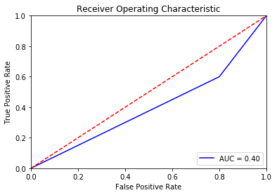
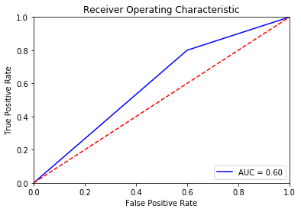
Figure 17 – KNN (Green)
Figure 18 - Naïve Bayes (Green)
Problem 2 - Classification
Figure 19 – CART (Green)
Figure 20 – Random Forest (Green)
Figure 21 – KNN (Hinselmann)
Figure 22 – Naïve Bayes (Hinselmann)
Figure 23 – CART (Hinselmann)
Figure 24 – Random Forest (Hinselmann)
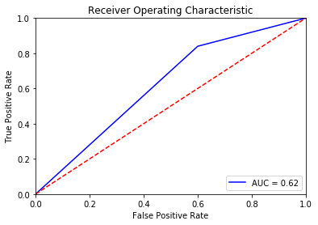
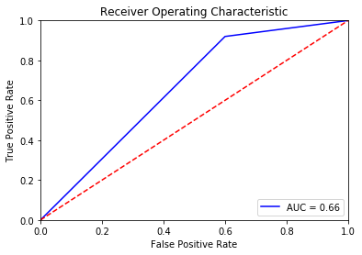

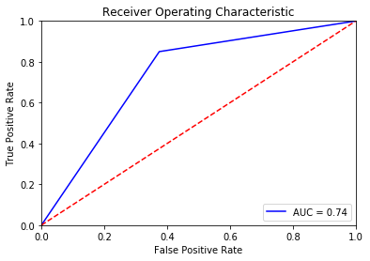
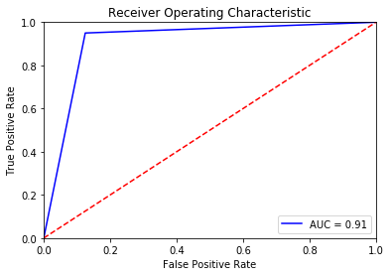
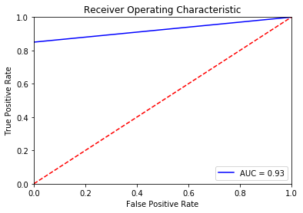
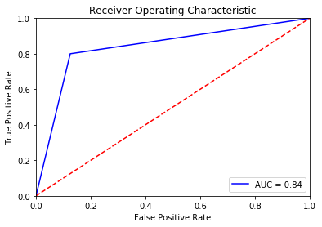
Figure 25 – KNN (schiller)
Figure 26 – Naïve Bayes (schiller)
Figure 27 – CART (schiller)
Figure 28 – Random Forest (schiller)

